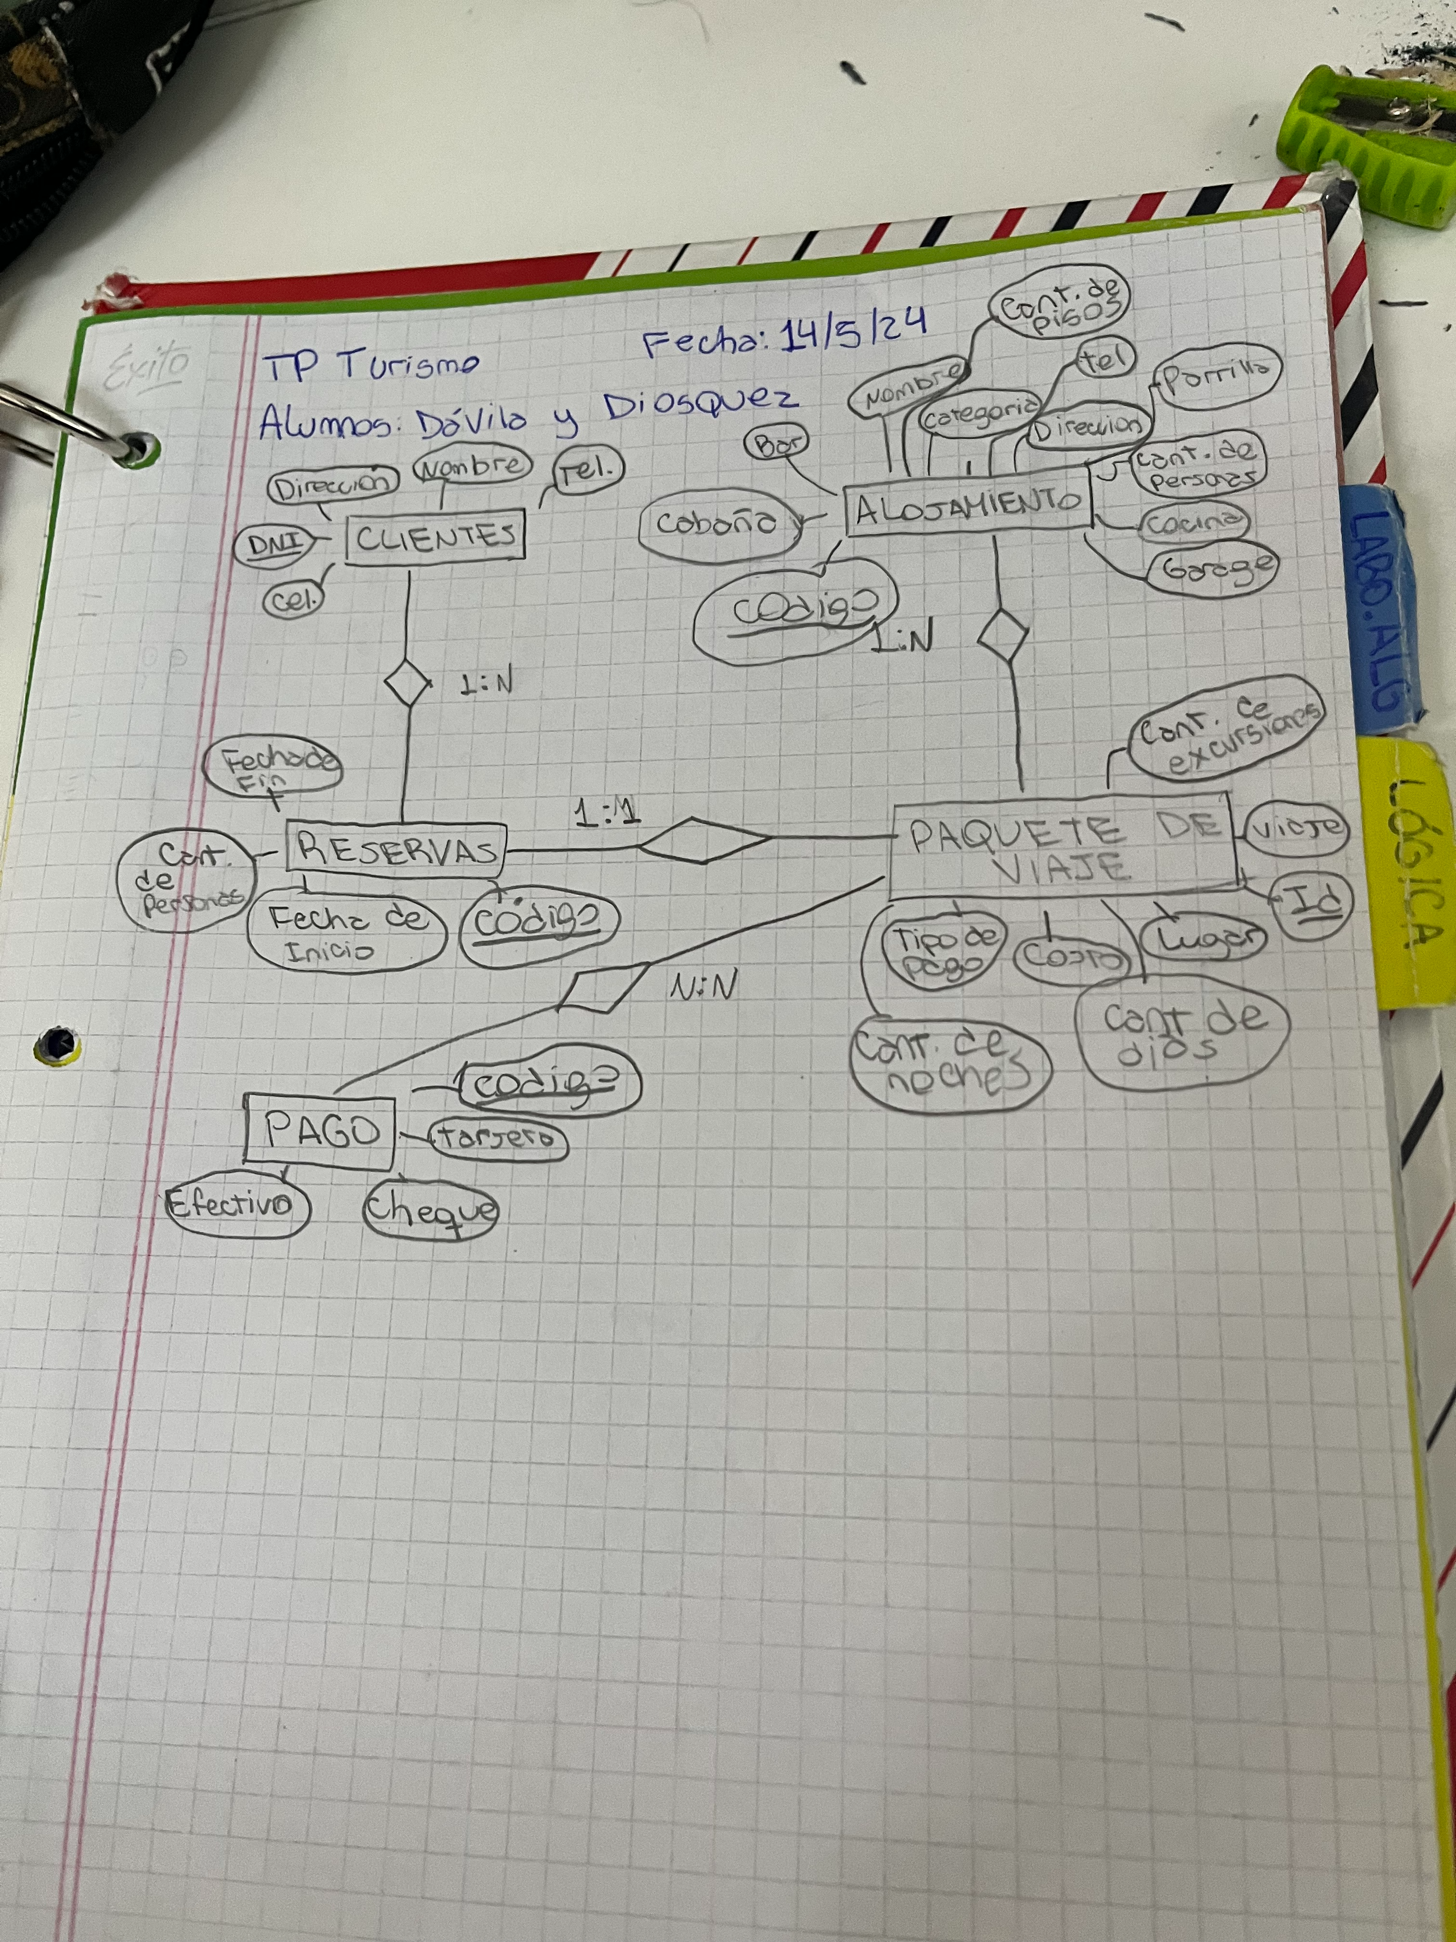
0
000

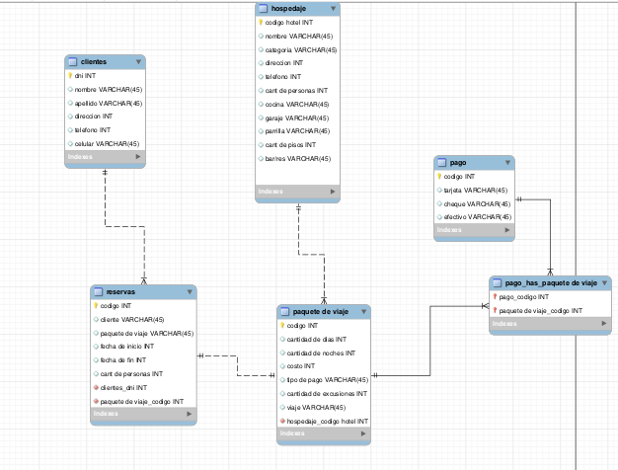

insert into clientes values(10001,"Andres","Garazalez","2775",549121,"Iphone x"),

(10002,"Joaquin","Duzckewick","2750",549212,"Google Pixel 7"),

(10003,"Felipe","Lorras","5720",579112,"Moto G40"),

(10004,"Maximo","Ritter","3524",55112,"Iphone 7"),

(10005,"Tomas","Golitre","892",969120,"Samsumng J5"),

(10006,"Santiago","Sarrena","9815",541928,"Samsumng A50"),

(10007,"Blas","Mokix","8520",515412,"Iphone 14"),

(10008,"Juan Cruz","Suarez","8898",154015,"Iphone 13"),

(10009,"Damian","Punic","7822",482720,"Iphone 15");

insert into hospedaje values ("1","Hotel A","5 Estrellas","10",1234567890,100,"SI","SI","SI",5,"SI"),

("2","Hotel B","3 Estrellas","20",1234567891,152,"NO","SI","SI",3,"SI"),

("3","Hotel C","1 Estrellas","30",1234567892,281,"SI","NO","SI",2,"NO"),

("4","Hotel D","5 Estrellas","40",1234567893,418,"SI","SI","NO",6,"SI"),

("5","Hotel E","6 Estrellas","50",1234567894,207,"SI","SI","SI",15,"SI"),

("6","Hotel F","2 Estrellas","60",1234567895,164,"SI","SI","SI",8,"SI"),

("7","Hotel G","4 Estrellas","70",1234567896,373,"SI","SI","SI",3,"SI"),

("8","Hotel H","5 Estrellas","80",1234567897,399,"SI","SI","SI",4,"SI"),

("9","Hotel I","3 Estrellas","90",1234567898,421,"SI","SI","SI",6,"SI"),

("10","Hotel J","4 Estrellas","100",1234567899,540,"SI","SI","SI",4,"SI");

INSERT INTO `paquete de viaje` VALUES(1, 10 , 9 , 200000 , "EFECTIVO" , 6 , "Avion"),

(2, 9, 8, 300000, "TARJETA", 7, "Auto"),

(3,11,10,400000,"EFECTIVO",5,"Avion"),

(4,5,4,500000,"TARJETA",4,"Avion"),

(5,6,6,600000,"EFECTIVO",3,"Auto"),

(6,7,6,700000,"EFECTIVO",5,"Avion"),

(7,8,7,800000,"EFECTIVO",4,"Auto"),

(8,9,8,900000,"TARJETA",7,"Avion"),

(9,12,12,10000000,"TARJETA",10,"Avion"),

(10,16,15,15000000,"EFECTIVO",12,"Auto");

insert into reservas values (100,"Pepito",1,2021-1-1,2021-1-10,4,10000,1),

(101,"Pedro",2,2017-5-5,2018-6-25,4,10001,2),

(102,"Iniesta",3,2007-5-31,2017-7-1,4,10002,3),

(103,"Puyol",4,2020-5-5,2021-9-6,4,10003,4),

(104,"Xavi",5,2020-9-9,2021-9-6,4,10004,5),

(105,"Messi",6,2020-9-9,2021-9-6,4,4,10005,6),

(106,"Neymar",7,2020-9-9,2021-9-6,4,10006,7),

(107,"Eto",8,2020-9-9,2021-9-6,4,10007,8),

(108,"Henry",9,2020-9-9,2021-9-6,4,10008,9),

(109,"Navas",10,2020-9-9,2021-9-6,4,10009,10);

insert into pago values (1,"santander", "efectivo", "si","1"),

(2,"santander", "tarjeta", "si","2"),

(3,"visa", "efectivo", "no","3"),

(4,"santander", "tarjeta", "si","4"),

(5,"visa", "efectivo", "no","5"),

(6,"santander", "tarjeta", "si","6"),

(7,"santander", "efectivo", "no","7"),

(8,"visa", "efectivo", "si","8"),

(9,"santander", "tarjeta", "no","9"),

(10,"visa", "tarjeta", "si","10");

insert into `pago_has_paquete de viaje` values (1,1),

(2,2),

(3,3),

(4,4),

(5,5),

(6,6),

(7,7),

(8,8),

(9,9),

(10,10);

select * from clientes ; -- 4

select * from clientes where dni = 10005; -- 5

select apellido , nombre, telefono , celular from clientes where apellido like "Gar%"; -- 6

select nombre, categoría, direccion from hospedaje join `paquete de viaje` on hospedaje.`paquete de viaje_codigo`= `paquete de viaje`.codigo left join reservas on `paquete de viaje`.codigo = reservas.`paquete de viaje_codigo` where `fecha de inicio` is null;

select * from clientes right join reservas on dni = clientes_dni where `fecha de fin`is null; -- 8

select apellido , nombre, telefono , celular from clientes where apellido like "%ez"; -- 9

update clientes set direccion = "San Juan 1234" where dni = 10009; -- 10

Select * from hospedaje where categoria="Cabaña"; -- 11

select * from `paquete de viaje` where `cantidad de dias` = 2 and costo > 6000; -- 12

select * from reserva where `fecha de inicio` >= '2017-05-01' and `fecha de fin` <= '2017-05-10' order by `fecha de inicio` , `fecha de fin` desc; -- 13

select costo, apellido, nombre,dni `tipo de pago` from clientes join reservas on dni= clientes_dni join `paquete de viaje` on `paquete de viaje_codigo` = codigo join pago on codigo = `paquete de viaje_codigo` ; -- 15

select * from hospedaje left join `paquete de viaje` on codigo = alojamiento_idalojamiento where `cant/dias` = null; -- 16

delete from reservas where clientes_dni= 10009; -- 14

update hospedaje set direccion= "Belgrano 15897" where `codigo hotel` = 3 ; -- 17
select * from reservas join `paquete de viaje` on `paquete de viaje`.codigo=`paquete de viaje_codigo` join hospedaje on hospedaje.codigo=`paquete de viaje_codigo` where `fecha de inicio` >= 2017/04/01 and `fecha de fin` <= 2017/04/30 and `cantidad de personas`>2;--18
select apellido, nombre, telefono, celular from clientes where apellido like "%ar%"; -- 19

delete from `paquete de viaje` where codigo=2;-- no deja borrar el paquete viaje porque la clave forania de la reserva

delete from clientes where dni = 10006;-- 21, no se puede porque tiene la clave forania de reservas

update `paquete de viaje` set `cantidad de dias` =7 and `cantidad de noches`=8 where viaje="Bariloche"; -- 22

